18.61: a) The absolute pressure of the gas in a cylinder is 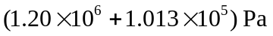 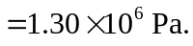 At atmospheric pressure, the volume of hydrogen will increase by a factor of 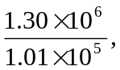 so the number of cylinders is

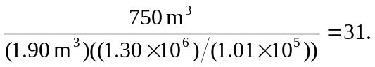

b) The difference between the weight of the air displaced and the weight of the hydrogen is

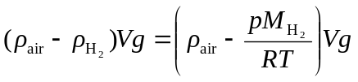

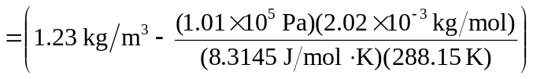

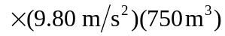

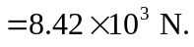

c) Repeating the above calculation with 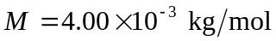 gives a weight of 